**JavaScript**

A single-threaded, non-blocking, asynchronous, concurrent language.

JavaScript has call stack, an event loop, a callback queue and other APIs.

It is a high-level, interpreted programming language - execute instructions directly and freely, without previously compiling a program into machine-language instructions. The interpreter executes the program directly, translating each statement into a sequence of one or more subroutines, and then into another language (often machine code).

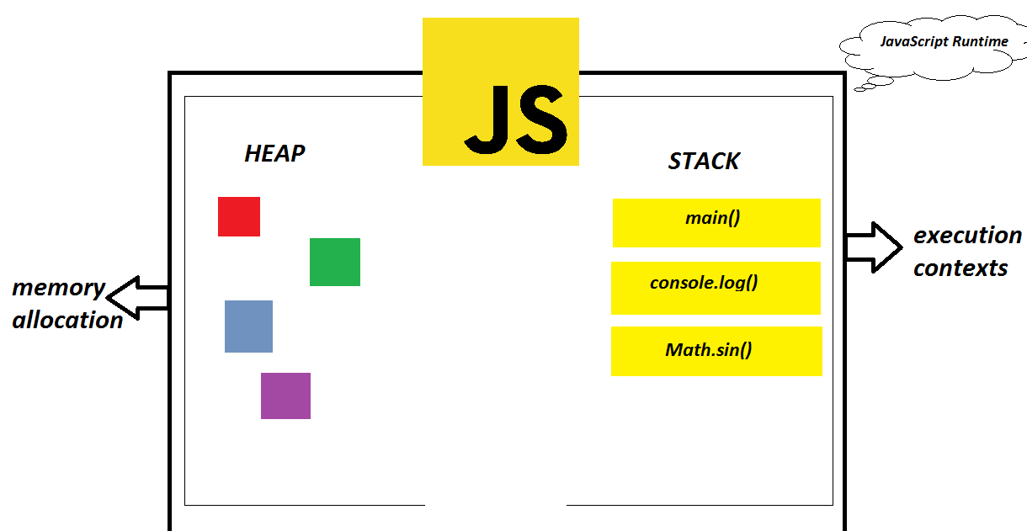

a.k.a JavaScript is a single threaded programming language(single threaded runtime) => single call stack => one thread == one call stack == one thing at a time.

